**Microchip-Logo with R.emfisUpdate Tool User Guide** V2.32

Table of Contents

1. Introduction 3

2. Tool Layout 4

3. Use Cases 6

3.1 Flash Firmware Update through COM Port 6

3.2 EEProm System-Configuration Update 8

3.3 Firmware Flash Update through USB 9

3.4 Flash Firmware Dump through COM Port 10

3.5 Firmware Images and Configuration Merge 12

4. Appendix A: HEX Images Collection (BM83 Only) 13

5. Appendix B: Intel HEX Format 13

Revision History 14

# Introduction

isUpdate is a highly integrated PC-based tool used for DFU(Device Firmware Update), memory access and system configuration of a series of Microchip Bluetooth embedded systems. Version 1.0x tool can be executed on Windows operation systems like 7, 8 and 10. It supports Microchip IS1670/1671, IS2062/2063/2064, IS2083, BM70/71, BM62/63/64 and BM83 embedded system ASICs and their derived modules through USB HID and RS232 interfaces. The major memory access operations include Flash Update/Dump, EEPROM Read/Write and EEPROM Table Dump/ Write. These features are listed as follows:

Memory Types supported:

Three types of memory are supported: flash, eeprom, and eMCU. Herein, five kinds of flash, including embedded flash, parallel flash, serial flash, DMA and PSRAM, are supported.

Note that the type eMCU means external microcontrollers and is used to access the memory of microcontrollers. Microcontrollers shall provide UART interface for communicating with Bluetooth embedded system.

Memory Access Functions supported:

Three functions are supported: Update, Rehex, Dump and Verify.

Update function is used to write data into the whole target memory for saving configurations by write memory command. Source files could be *.HEX file, *.HXX files, and *.BIN file.

Rehex function is used to integrate all existing files then export to one *.HEX file, which the data is aligned by 16 bytes and the address offset is arranged in ascending order.

Dump function is used to read data from target devices by read memory command. Result data could be stored as *.txt files.

Verify function, which is supported in flash memory type, is used to compare the difference between readout data from device and data from an existing image file. This is used to confirm that Update procedure is done successfully.

Hardware Interfaces supported:

Two interfaces including USB HID and RS232 are supported.

Target Embedded System supported:

IS1670/1671, IS2062/2063/2064, IS2083, BM70/71, BM62/63/64 and BM83 are supported.

Platform Compatibility:

Mandatory for Windows 7/8/10.

# Tool Layout

There are five parts on isUPdate Tool layout: Access Port, Memory Type, Code Information/Version, Flash Update/Dump and Flash/EEPRom/MCU/AHB Access.

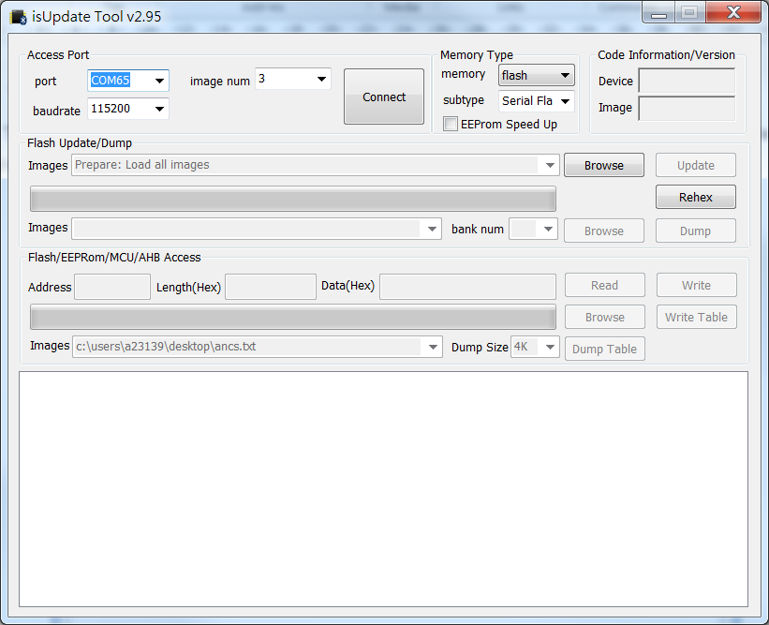

* Access Port:

Options of COM port and USB HID interfaces are provided. Remember to assign baudrate if COM port is selected. Then click the Connect button to open related port and create the connection to the target device.

* Memory Type:

User could choose the type of memory (flash, eeprom or eMCU) he/she is going to access. Subtype will be automatically assigned by tool.

For speeding up the process of eeprom writing, the EEProm Speed Up option only affects the eeprom writing and is provided to reduce time waste.

* Code Information/Version:

Target device firmware code information will be displayed in “Device” field once device is connected successfully. As for “Image” field, a txt file of EEProm table shall be loaded (with **Browse** and select file from PC) first, then isUpdate will acquire and parse IC/FW version information from this EEProm file.

* Flash Update/Dump:

In the connected status, user could update or dump the flash memory (firmware) with related “Browse” button. The Browse button near the Update button is used to select hex files ready for downloading to target device. Another Browse button near the Dump button is used to select a folder in PC for saving target device’s firmware hex files. During update and dump, the progress bar would show the progress of related operation.

The Rehex button, for a particular purpose, users could import firmware images and generate a .hex file which the data of each line is aligned to 32 bytes and a .bin file. Rehex .ini option is used to regenerated a .hex file for IS2083 and BM83.

* Flash/EEPRom/MCU/AHB Access:

It is used to read/write a specific range of EEProm or write/dump a full EEProm table. For the specific range of EEProm read/write, Address, Length and Data (for write only) shall be properly assigned.

# Use Cases

Three major purposes of isUpdate tool are device firmware update through UART, system configuration update and device firmware update through USB. These use cases will be introduced in following sections.

## Flash Firmware Update through COM Port

Please follow the procedures described below to update flash firmware through UART COM port. To understand which images collection can be updated, please refer to APPENDIX A.

* Note that when updating the Config.HEX, the runtime configuration sector will be erased.
* Note that when updating the DSP.HEX, the previous VP data might be erased. (if the sector of DSP.HEX will overlap the sector of previous VP data.)
* 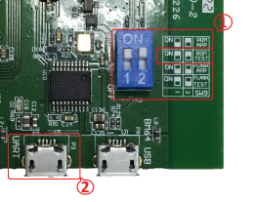Hardware Setup:

**➀** Properly configure (by switches) target device to run on ROM_TEST mode.

**➁** Wire the computer to the “UART” connector of the target EVB (physically, it is the micro USB receptacle with “UART” printed nearby).

* FlashHeader_Config.ini Editing (BM83 only)

For BM83 flash update, the INI file is stored as FlashHeader_Config.ini that contains information of flash address offset values of 8051 firmware code and DSP code. Please follow steps below to edit FlashHeader_Config.ini. Until now, settings in FlashHeader_Config.ini don’t be changed only if the flash layout has been changed.

Do not change any contents in **[FlashHeader]**, **[IB_FW]**, **[IB_FW_FileDescriptor]** and **[IB_DSP_Descriptor]**.

* 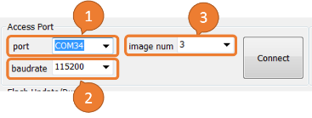Launch isUpdate tool and Configure COM port settings in “**Access Port”** area:

**➀**Select correct port number(check your computer with the COM port number assigned for the target device) in “**port”** drop down menu.

**➁** Assign “**baudrate”** to "**115200**".

**➂** Select correct number of image files in “**image num”** drop down menu.

* 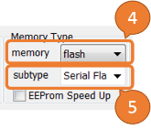Configure **Memory Type**:

**➃** Select "**flash**" in “**memory”** drop down menu.

**➄** Select "**Serial flash”** in “**subtype”** drop down menu.

* Flash Upgrade:

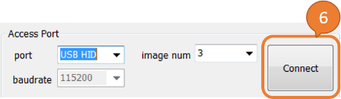 **➅** Click “**Connect”** button.

Once UART connection has been established successfully, buttons in “**Flash Update/Dump”** area are activated.

**➆** After clicking the upper “**Browse”** button near “**Update”** button, a dialog will pop up for user to grab image files from PC.

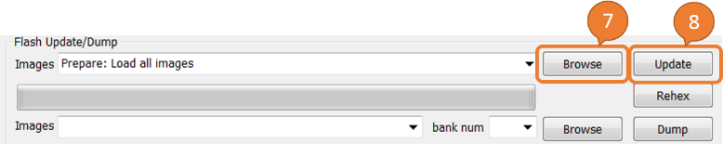 **➇** Click “**Update”** button, then the progress bar will show real-time progress of flash updating.

## EEProm System-Configuration Update

Please follow the procedures described below to update E2PROM through UART COM port.

* 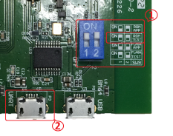Hardware Setup:

**➀** Properly configure(by switches) target device to run on ROM_TEST mode.

**➁** Wire the computer to the “UART” connector of the target EVB.

* Launch isUpdate tool and Configure COM port settings in “**Access Port”** area:

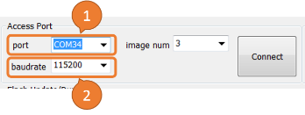 **➀** Select correct port number in “**port”** drop down menu.

**➁** Assign “**baudrate”** to "**115200**".

* 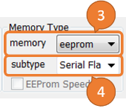Configure **Memory :**

**➂** Select "**eeprom**" in “**memory”** drop down menu.

**➃** Select "**default**" in “**subtype”** drop down menu.

* EEProm Update

**➄** Click **Connect** button

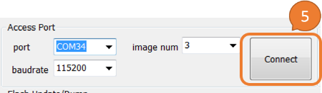Once UART connection has been established successfully, all buttons functions in the “**Flash/EEProm/MCU/AHB Access”** area are activated.

**➅** Click the lower “**Browse”** button near “**Write Table”** button, a dialog will pop up for user to grab an EEProm content files from PC.

**➆** Click “**Write Table”** button, the progress bar will show the real-time progress of EEProm updating.

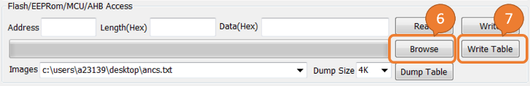

## Firmware Flash Update through USB

Please follow the procedures described below to update flash firmware through USB. To understand which images collection can be updated, please refer to APPENDIX A.

* Note that when updating the Config.HEX, the runtime configuration sector will be erased.
* Note that when updating the DSP.HEX, the previous VP data might be erased. (if the sector of DSP.HEX will overlap the sector of previous VP data.)
* 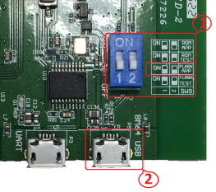Hardware Setup:

**➀** Properly configure (by switches) target device to run on FLASH_APP mode.

**➁** Wire the computer to the “USB” connector (a physical micro USB receptacle with “USB” printed nearby) of the target EVB.

* FlashHeader_Config.ini Editing (BM83 only)

For BM83 flash update, the INI file is stored as FlashHeader_Config.ini that contains information of flash address offset values of 8051 firmware code and DSP code. Please follow steps below to edit FlashHeader_Config.ini. Until now, settings in FlashHeader_Config.ini don’t be changed only if the flash layout has been changed.

Do not change any contents in **[FlashHeader]**, **[IB_FW]**, **[IB_FW_FileDescriptor]** and **[IB_DSP_Descriptor]**.

* Launch isUpdate tool and Configure COM port settings in “**Access Port”** area:

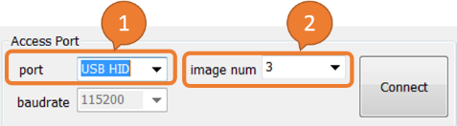 **➀** Select "**USB HID**" in “**port”** drop down menu.

**➁** Select correct number of image files in “**image num”** drop down menu.

* 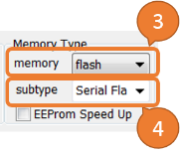Configure **Memory Type**:

**➂** Select "**flash**" in “**memory”** drop down menu.

**➃** Select "**Serial flash”** in “**subtype”** drop down menu.

* Flash Upgrade:

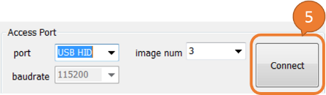**➄** Click “**Connect”** button

Once USB connection has been established successfully, all buttons in “**Flash Update/Dump”** area are activated.

**➅** After clicking the upper “**Browse”** button near “**Update”** button, a dialog will pop up for user to grab image files from PC.

**➆** Click “**Update”** button, then the progress bar will show real-time progress of flash updating.

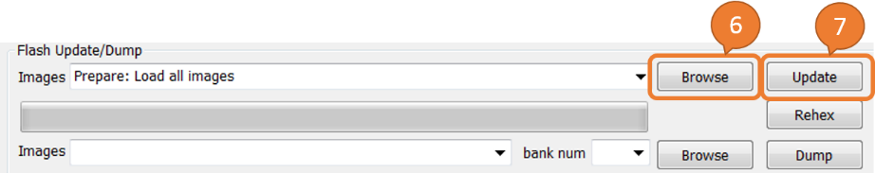

## Flash Firmware Dump through COM Port

Please follow the procedures described below to dump data from flash firmware through UART COM port.

* Hardware Setup:

**➀** Properly configure (by switches) target device to run on ROM_TEST mode.

**➁** Wire the computer to the “UART” connector of the target EVB (physically, it is the micro USB receptacle with “UART” printed nearby).

* Launch isUpdate tool and Configure COM port settings in “**Access Port”** area:

**➀** Select correct port number(check your computer with the COM port number assigned for the target device) in “**port”** drop down menu.

**➁** Assign “**baudrate”** to "**115200**".

**➂** Select correct number of image files in “**image num”** drop down menu.

* 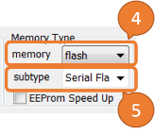Configure **Memory Type**:

**➃** Select "**flash**" in “**memory”** drop down menu.

**➄** Select "**Serial flash”** in “**subtype”** drop down menu.

* Flash Dump:

**➅** Click “**Connect”** button.

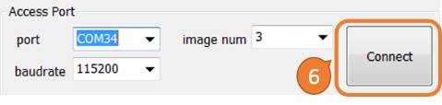Once UART connection has been established successfully, buttons in “**Flash Update/Dump”** area are activated.

**➆** Select number of exporting image files in “**bank num”** drop down menu.

**➇** After clicking the lower “**Browse”** button near “**Dump”** button, a dialog will pop up for user to specify the directory/folder in PC.

**➈** Click “**Dump”** button, then the progress bar will show real-time progress of flash dumping or the Dump dialogue will be pop-up (BM83 Only).

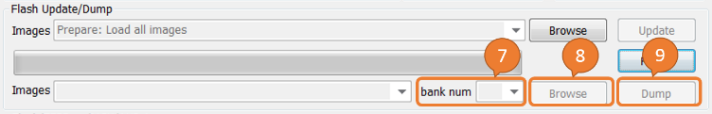

* Dump dialogue (BM83 Only), which provides many options for code and data dump, they are

**MCU Code:** Export a *.HEX image including the active MCU firmware.

**DSP Code**: Export a *.HEX image including the active DSP firmware.

**Voice Prompt Data**: Export a *.HEX image including the active voice prompt data.

**UI Config:** Export a *.HEX image including UI config data.

**Entire Flash:** Export a *.HEX image the entire flash.

**Effective Flash:** Export a *.HEX image including active MCU firmware, active DSP firmware, active voice prompt data and UI config data.

**BD Linkkey:** Export a *.HEX image including the specific sector which stores paired device record(remote Bluetooth device address). The useful information of paired device record will be printed out in the bottom of the *.HEX file.

**IB**: Export a *.HEX image including the data stored in information block sector, e.g. Local Bluetooth address.

isUpdate tool reads out the data from DUT to get what code and data storage in the flash memory and options will be activated for choosing.

⑩ Choose one checkbox or multiple checkboxes

⑪ Click “**Apply”** button, then the progress bar will show real-time progress of flash dumping and save the code/data as files.

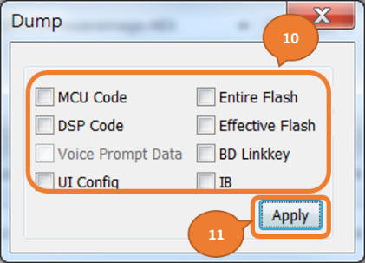

## Firmware Images and Configuration Merge

Please follow the procedures described below to merge the selecting files and images to save as a *. HEX file. To understand which images collection can be merged, please refer to APPENDIX A.

* Files/Images Merge:

**➀** After clicking the lower “**Browse”** button near “**Update”** button, a dialog will pop up for user to grab image files from PC.

**➁** Click “**Rehex”** button and the Rehex dialogue will show up.

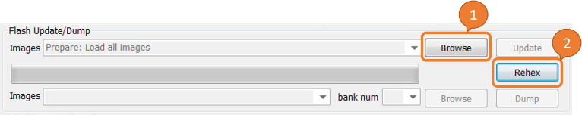

**➂** Choose one of three options,

**BM6x/BM7x General Use**: Export a *.HEX file for BM6x and BM7x.

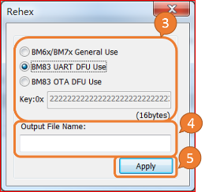**BM83 UART DFU Use**: Export a *.HEX file for BM83, must be used by isUpdate tool in TEST mode or external MCU/SPKCommandSet tool in APP mode.

**BM83 OTA DFU Use**: Export *.HEX file for BM83 OTA DFU, must be used by mobile app in smart phones, you must key-in your own OTA DFU key.

**➃** Fill your file name in “**Output File Name”** field if you’d like to re-name the rehex file, otherwise, the name of rehex file would be the name of source image file with checksum.

**➄** Click **“Apply”** button then the progress bar will show real-time progress of images merging and one *.HEX file will be exported.

# Appendix A: HEX Images Collection (BM83 Only)

For BM83, there are four kinds of flash images which isUpdate tool v2.46 supports:

1. **MCU.HEX** which is MCU code
2. **DSP.HEX** which is DSP code and regenerated by DSP.c files
3. **CONFIG.HEX** which is generated by UI and DSP config tool and may have VP data or not. When the update list includes the CONFIG.HEX and the update progress starts, a pop-up message of “Clear paired devices record?” let users decide to.
4. **FULL.HEX** which is generated by isUpdate tool and includes the data of MCU.HEX, DSP.HEX, CONFIG.HEX and the information of flash header.

Hence the use cases could be many collections of HEX images, the case collections can be performed are listed as bullet items below.

1. MCU.HEX case
   * Update without any *.HEX files
   * Update with DSP.H­­EX
   * Update with CONFIG.HEX excluding VP Data
   * Update with DSP.HEX and CONFIG.HEX including VP Data
   * Update with DSP.HEX and CONFIG.HEX excluding VP Data
2. DSP.HEX case
   * Update with MCU.HEX
   * Update with MCU.HEX and CONFIG.HEX including VP Data
   * Update with MCU.HEX and CONFIG.HEX excluding VP Data
3. CONFIG.HEX including VP Data case
   * Update with MCU.HEX and DSP.HEX
4. CONFIG.HEX excluding VP Data case
   * Update without any *.HEX files
   * Update with MCU.HEX
   * Update with MCU.HEX and DSP.HEX
5. FULL.HEX case
   * Update without any HEX files

# Appendix B: Intel HEX Format

The file format of *.HEX file is Intel HEX format, please reference <http://www.keil.com/support/docs/1584/> and <https://en.wikipedia.org/wiki/Intel_HEX> to understand more details.

# Revision History

|  |  |  |  |
| --- | --- | --- | --- |
| Version | Date | Corresponding tool Version | History |
| V1.00 | 2018/08/23 | isUpdate tool V2.30 | First version |
| V1.10 | 2018/10/18 | isUpdate tool V2.43 | Change the figure of tool layout |
| V1.20 | 2018/10/30 | isUpdate tool v2.44 | Change naming of BT55XX to IS167X/206X/2083 and BM6X/7X/8X  Add one step into chapter 3.5 |
| V2.00 | 2019/01/11 | isUpdate tool v2.47 | Add a section of APPENDIX A |
| V2.10 | 2019/08/15 | isUpdate tool v2.80 | Change the flow of chapter 3.5 |
| V2.20 | 2020/01/06 | isUpdate tool v2.90  isUpdate tool v2.91 | Change the flow and the picture of chapter 3.5  Add description of updating Config.HEX in chapter 3.1 |
| V2.31 | 2020/04/01 | isUpdate tool v2.94  isUpdate tool v2.95 | Update figures  Add description for options in Dump dialogue in chapter 3.4 |
| V2.32 | 2020/04/17 | isUpdate tool v2.96 | Update the screenshot for Dump dialogue in Chapter 3.4  Add detailed information to BD Linkkey in chapter 3.4  Add description for Intel HEX format in APPENDIX B |